# RMIT SEPT Major Project - Milestone 2

Group 2, Thu 10:30

## Members

* CAVE, Luca (s3787946)
* GAO, Richard (s3784324)
* HODGEN, Chris (s3031209)
* MCKEOWN, Ryan (s3718888)

## Records

* Github repository :

<https://github.com/RMIT-SEPT/majorproject-3-thurs-10-30-2>

* Notion Workspace : <https://www.notion.so/a09420a41c894ceebaf52ca6fa763fa9?v=0fbc91329684401fa1c305878586b72c>
* Document Store (also in the docs folder of repo master branch): <https://drive.google.com/drive/u/1/folders/1tSoAqlZNJXZqz89h_0aPGoGl2qPSMhRR>
* Live application:

Frontend: <https://agme.herokuapp.com/>

Backend: <http://agmeapi-env.eba-aw96pwjm.us-east-1.elasticbeanstalk.com/>

* Circle CI: <https://app.circleci.com/pipelines/github/RMIT-SEPT/majorproject-3-thurs-10-30-2>

## Milestone summary

### Sprint 2:

* React user dashboard
* React booking form
* React business form & connection to backend
* Business class, controller and service
* Booking class, controller and service
* Misc Booking and Business tests

### Sprint 3:

* Docker containers for front and back end
* Docker compose to coordinate containers
* Terraform infrastructure setup
* Heroku deployment
* AWS deployment

## Screenshots

Homepage

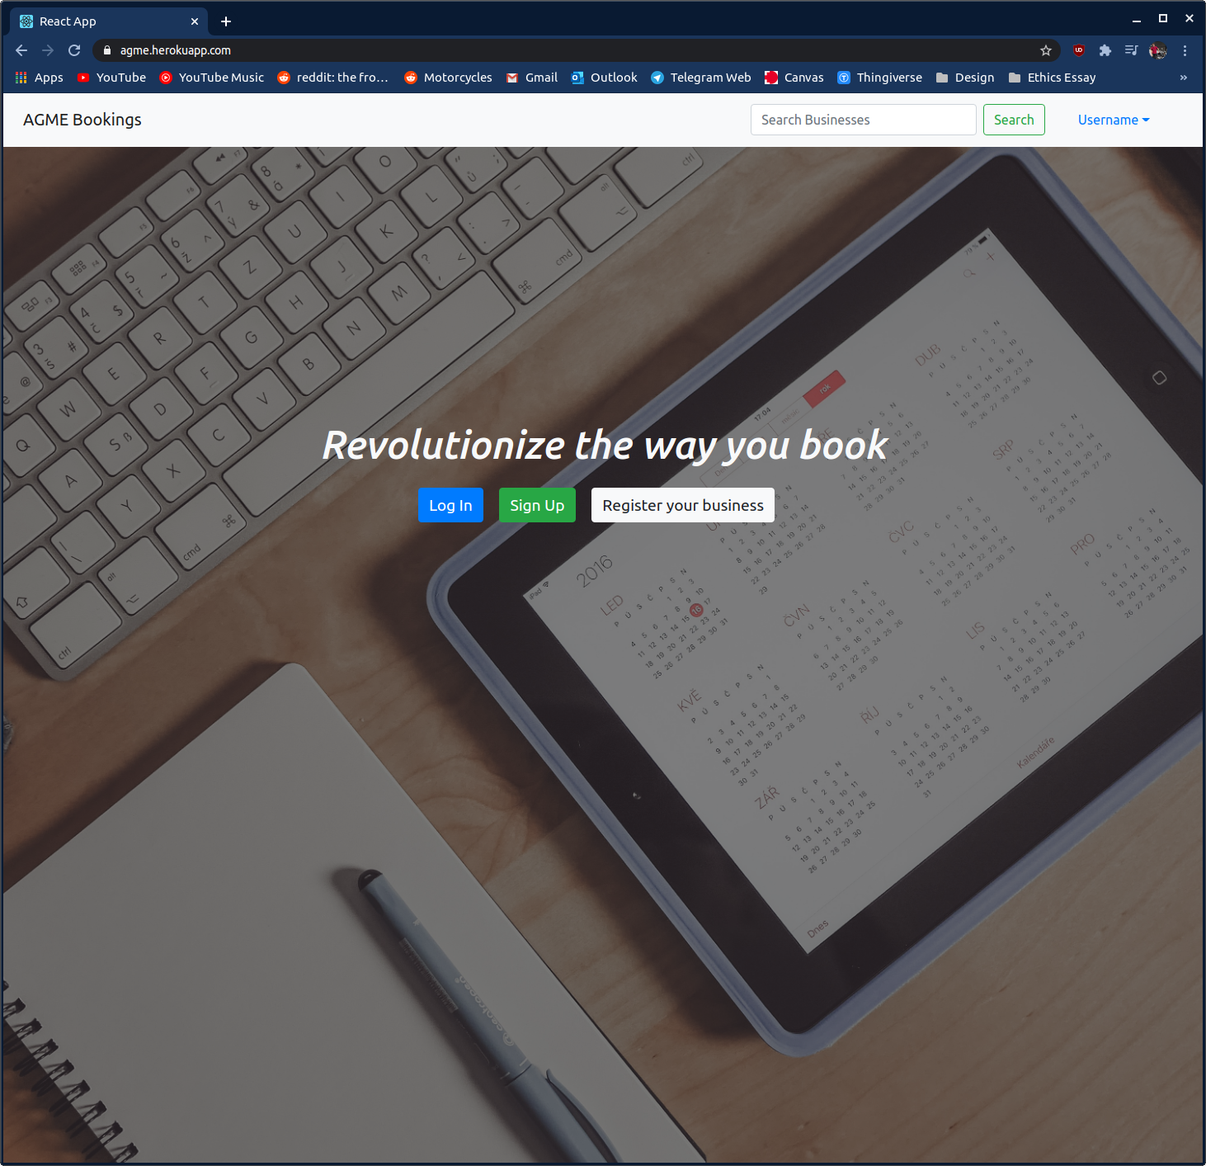

Login form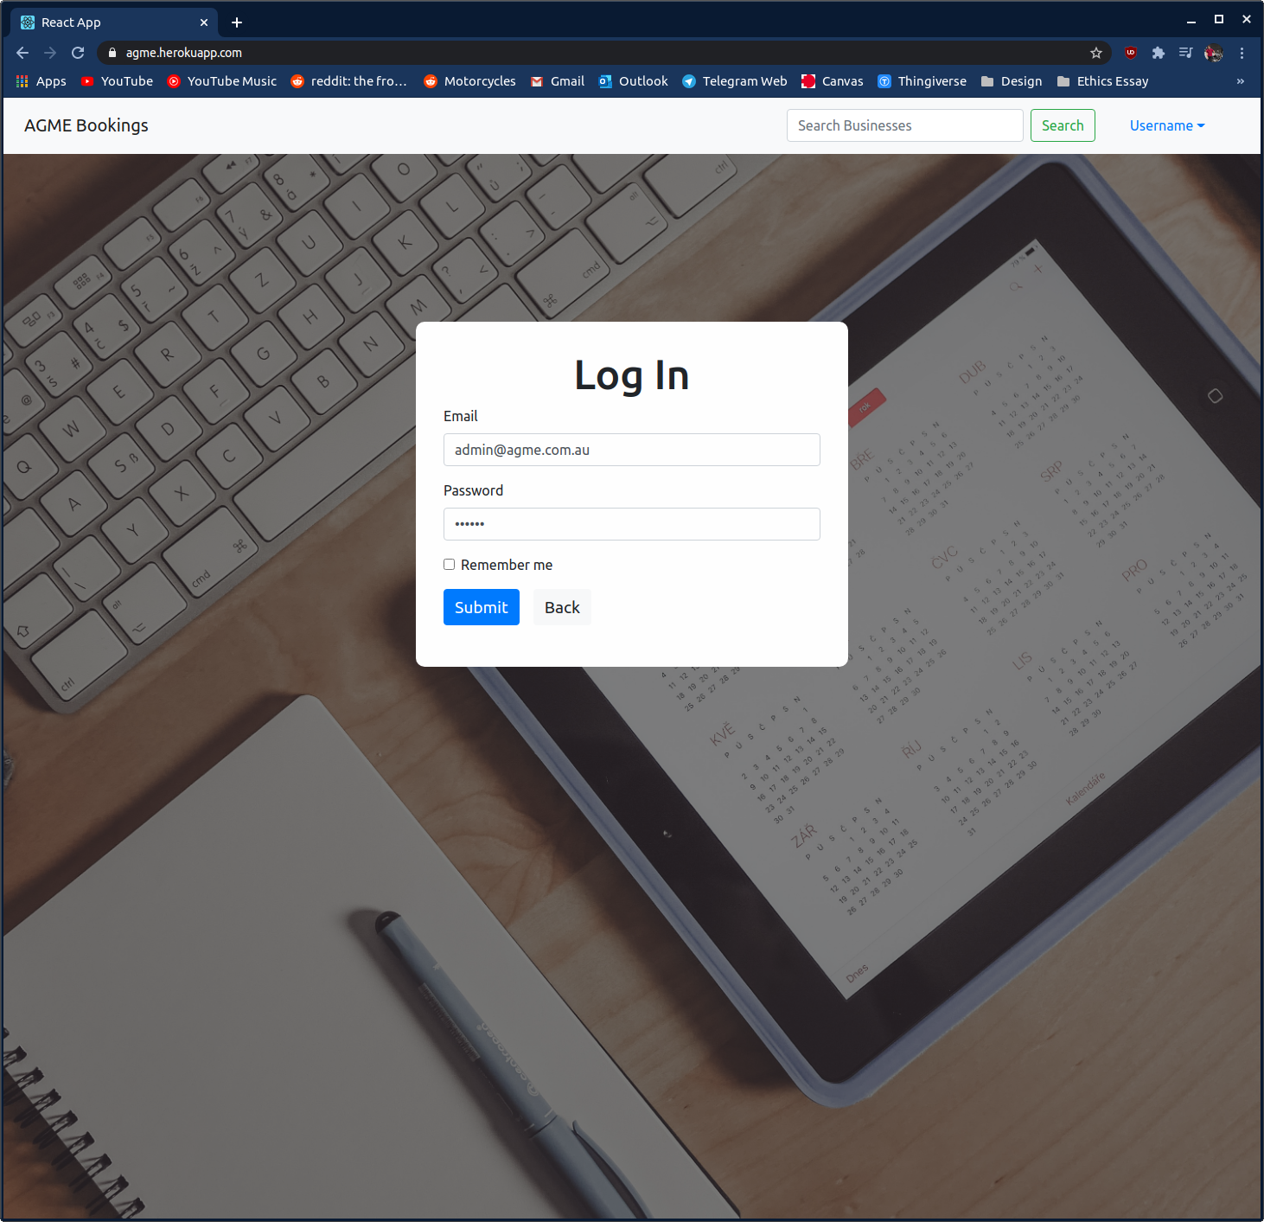

Dashboard

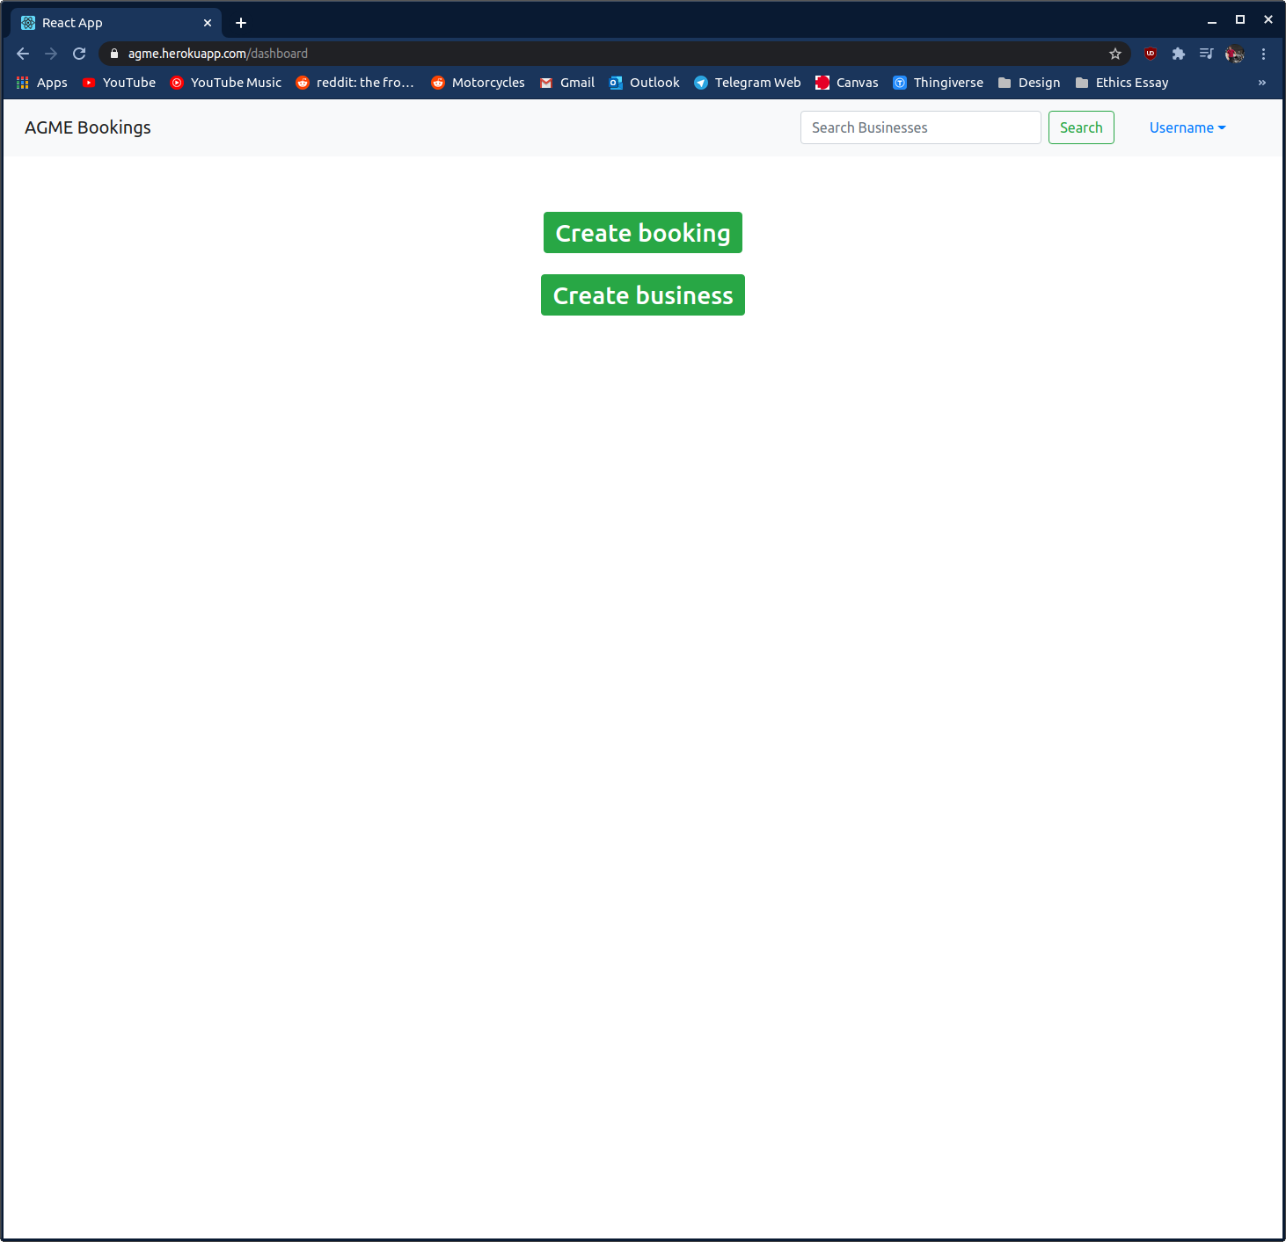

Booking form

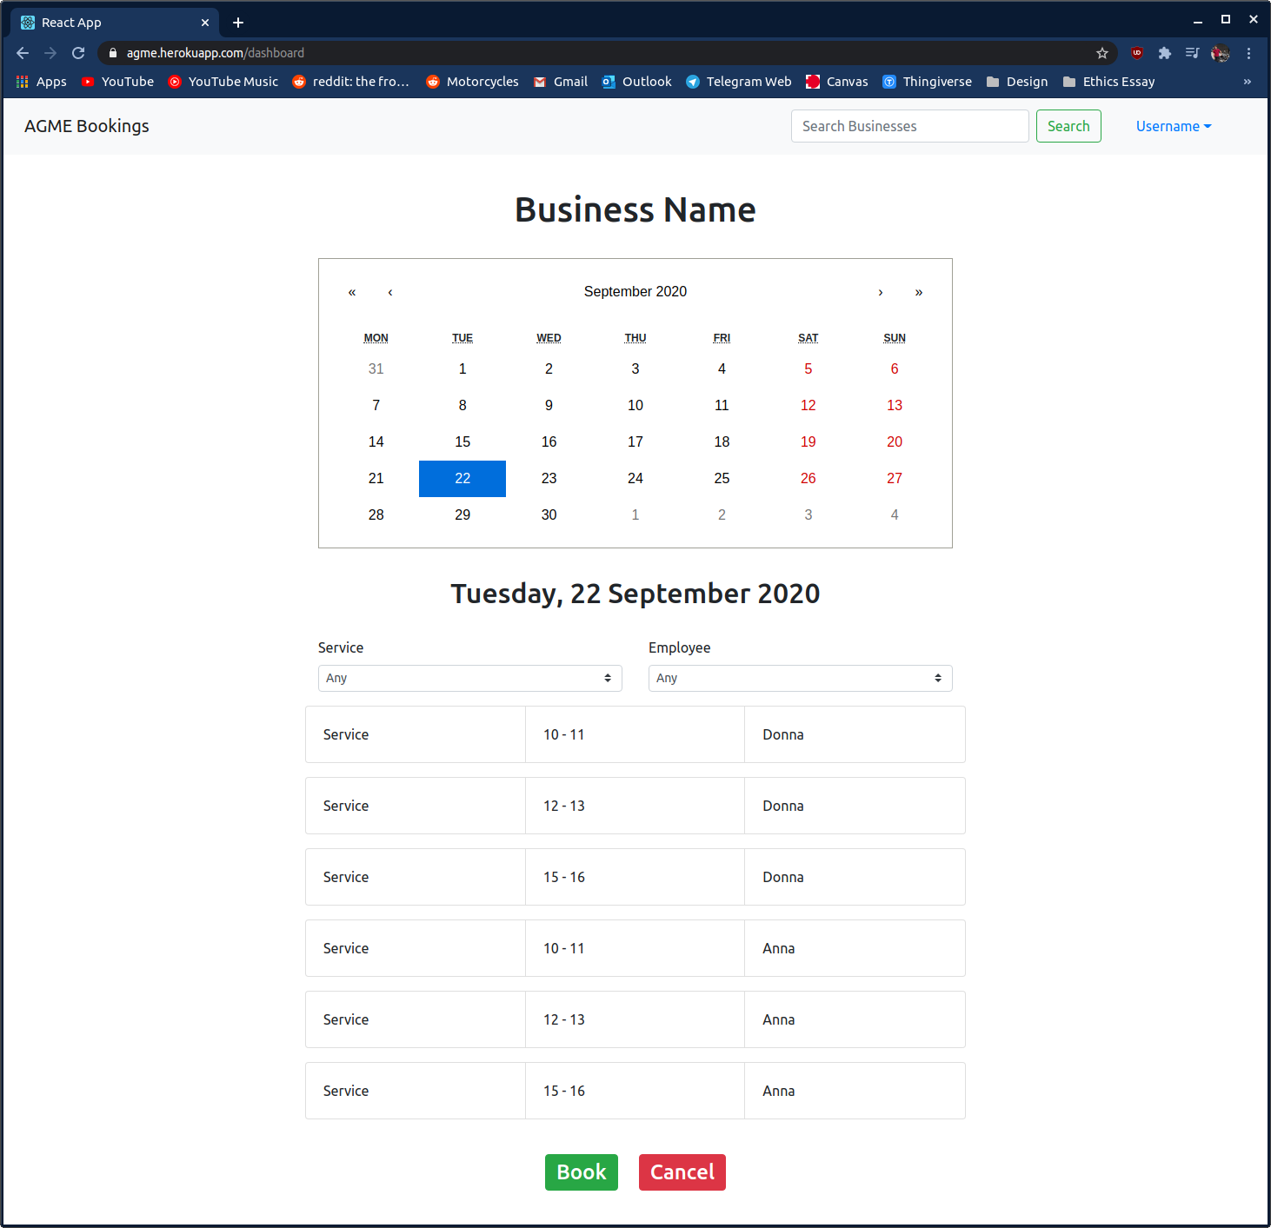

Business registry form

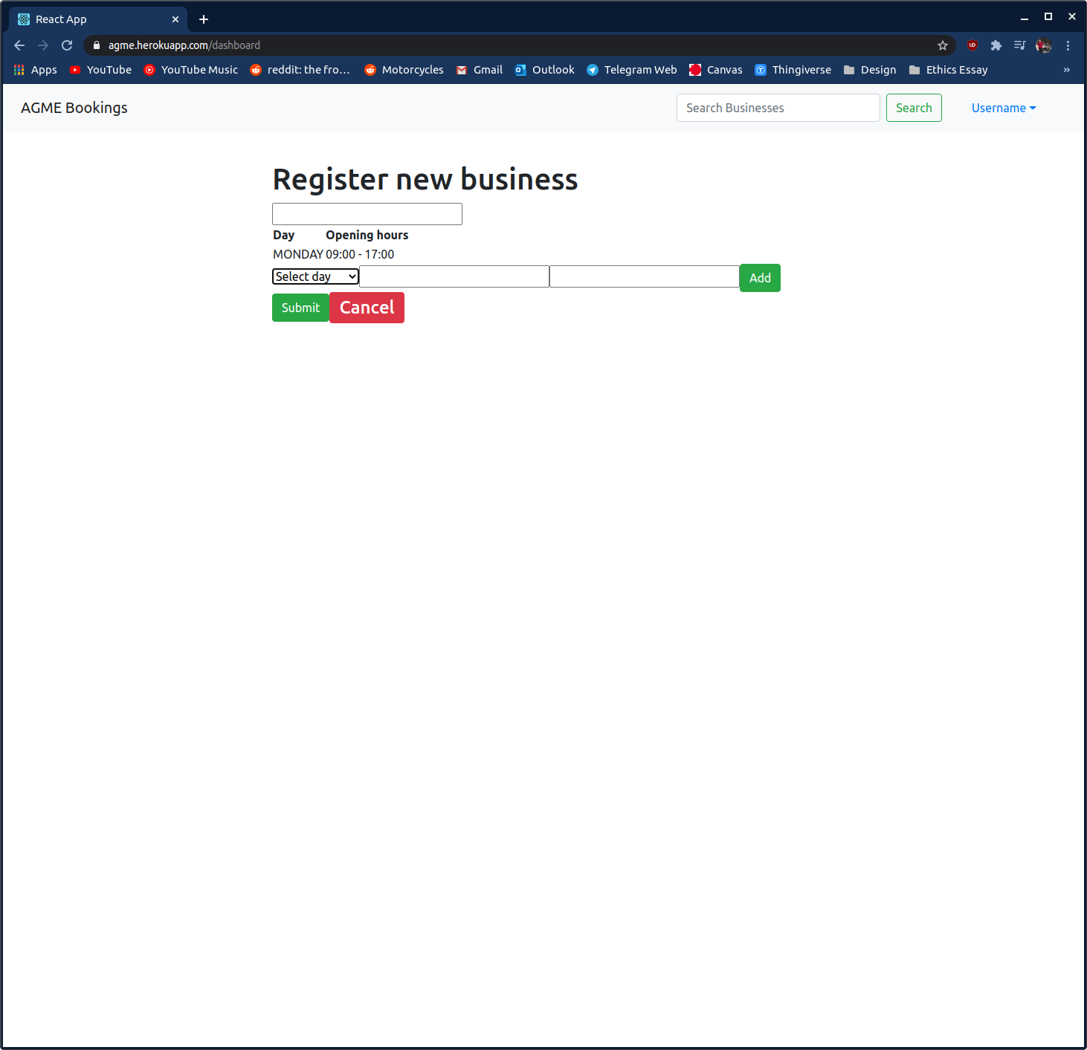

Businesses index

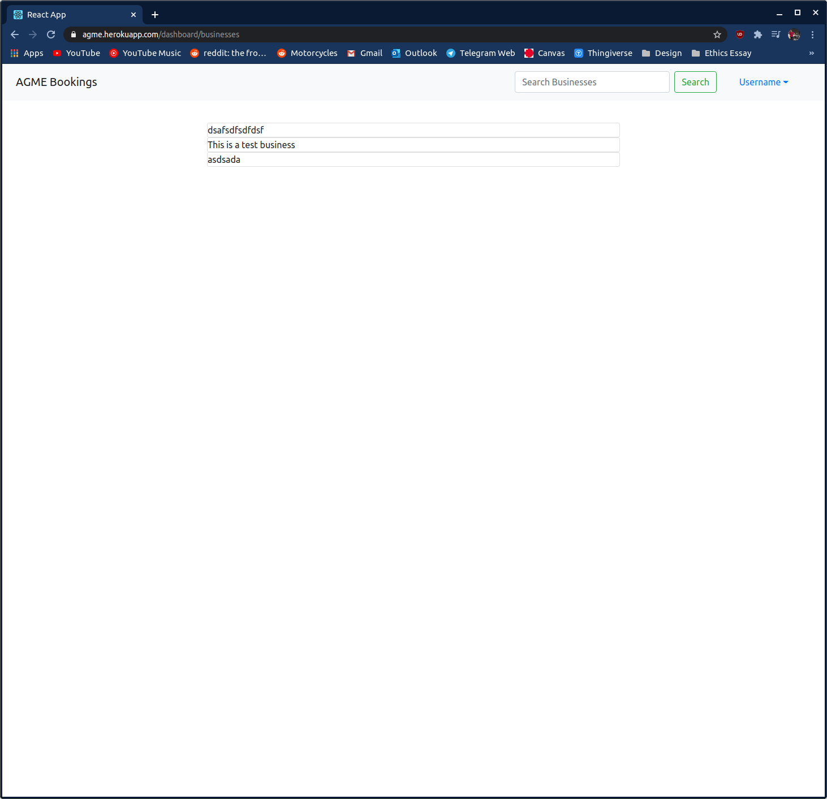

CircleCI out of credits

